Medical ACT Stakeholder Engagement Session 6
Summary of Discussions and Stakeholder Feedback

Thursday 1st May 2025

-----------------------------------------------------------------
 |  |  |  | 

Overview
The 6th Medical ACT Stakeholder event was held virtually on 1st May 2025 and was facilitated by Graham Paxton (Principal Lead, NES Organisational Development Leadership and Learning).
The agenda focused on Measurement of Teaching (MoT), Major Investment (previously referred to as Capital Investment) and the recently reviewed Medical ACT Travel and Accommodation Guidance. The morning concluded with an introduction to the new ScotCOM Primary Medical Qualification (PMQ) programme, delivered on behalf of St Andrews University.
The event brought together representatives from NHS Education for Scotland, NHS Boards and PMQ Programmes. On this occasion, 49 stakeholders were in attendance, in keeping with the strong engagement that has been present at all of the previous events.
Professor Emma Watson and Mr Jim Boyle began the morning by welcoming stakeholders and set the scene for the Medical ACT landscape in advance of the main agenda. They both emphasised the importance of co-creation and stakeholder collaboration in shaping the funding of medical education and acknowledged the progress made throughout the process so far.

Attendance
 | August ‘23 | November ‘23 | March ‘24 | June ‘24 | November ‘24 | May ‘25
Total Attendance | 44 | 47 | 48 | 51 | 55 | 49
In person | 36 | 21 | n/a | n/a | n/a | n/a
Online | 8 | 26 | 48 | 51 | 55 | 49
Directors of Medical Education | 12 | 6 | 12 | 13 | 13 | 9
Medical Education Manager | N/A | 10 | 8 | 9 | 7 | 5
Medical ACT Officer | N/A | 4 | 5 | 4 | 5 | 5
Medical ACT Finance Representatives | 9 | 6 | 4 | 5 | 5 | 6
UG Programme Leads | 5 | 7 | 4 | 3 | 5 | 4
GP Head of Teaching | 3 | 4 | 4 | 3 | 3 | 3
Other - including NES Team | 17 | 10 | 11 | 14 | 17 | 17

Topic 1: Measurement of Teaching (MoT)
Geraldine Brennan APGD and Ellie Biddulph Senior Finance Business Partner presented this session and covered the following areas that were acknowledged to be challenging:
- The current MoT process is data-heavy, time-consuming, and complex to collect especially for Category B (student-focused) teaching data.
- Stakeholders expressed frustration with the administrative burden of MoT and lack of clarity around the recording of sub-categories.
- 3 potential options for reform were then outlined by the NES team.
- Stakeholders were asked to provide views on the pros and cons of each on a virtual whiteboard, to help co-produce a future direction for reform.

Proposed future options for collating MoT
 | Option 1: Continue with the Current Process | Option 2: Proportional Allocation Using Only Cat A (Student Weeks) | Option 3: Proportional Allocation Using Both Cat A and Cat B
Key Points | - Maintain the existing MoT model using both Category A (Cat A) and Category B (Cat B) data.  - Cat A: Patient-focused teaching (e.g., clinics, ward rounds).  - Cat B: Student-focused teaching (e.g., tutorials, simulation, CPD). | - Allocate funding based solely on the number of Cat A student weeks.  - Boards and programmes agree on the proportion of student weeks delivered.  - Cat B data would be excluded from the model. | - Allocate funding based on agreed proportions of both Cat A and Cat B teaching to be delivered.  - Boards and programmes jointly determine the split (e.g., 70% Cat A, 30% Cat B).  - Requires periodic review (e.g. every 3–5 years).
Pros (NES perspective) | - Familiar and established process.  - Allows detailed tracking of teaching activity.  - Cat A data is generally robust and well-understood. | - Simpler and faster to collect and process.  - Reduces administrative workload significantly.  - Cat A data is already well-tracked and reliable. | - Balanced and fairer representation of all teaching activities.  - Recognises both patient- and student-focused contributions.  - Funding movements are more volatile than Option 2.
Cons (NES perspective) | - Highly complex and time-consuming, especially for Cat B.  - Cat B data is not used for any other purposes and is difficult to validate.  - Administrative burden on Boards and Medical ACT officers. | - Ignores Cat B teaching, which may undervalue some Boards’ contributions.  - May disadvantage co-located Boards that provide more student-focused teaching.  - Could lead to funding shifts and perceived inequities. | - More complex to implement than Option 2.  - Requires agreement on Cat A/Cat B ratios and proportional contributions.  - Still involves some administrative effort, though will ultimately be less than Option 1.
Option 1 - Continue current process with minor improvements
Poll:
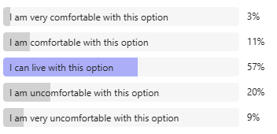
Pros and Cons:
Themes from the whiteboard activity are outlined below. A full list of pros and cons from the session can be found in Appendix 1.
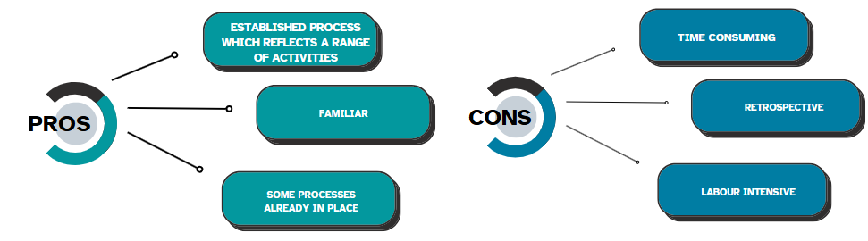
Option 2 - Use only Category A (patient-focused) student weeks for funding allocation
Poll:
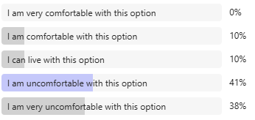
Pros and Cons
Themes from the whiteboard activity are outlined below. A full list of pros and cons from the session can be found in Appendix 1.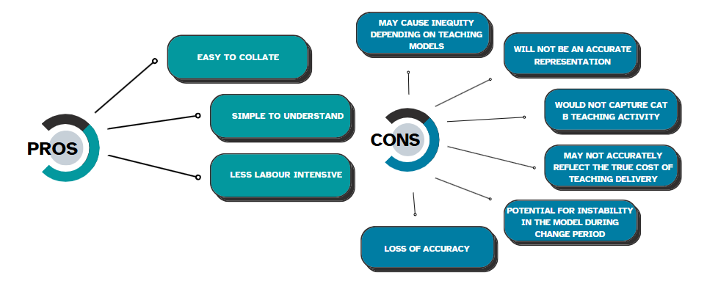
Option 3 - Use a proportional approach combining both Category A and B teaching
Poll:
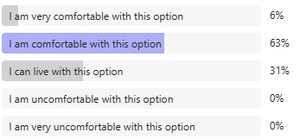
Pros and Cons
Themes from the whiteboard activity are outlined below. A full list of pros and cons from the session can be found in Appendix 1.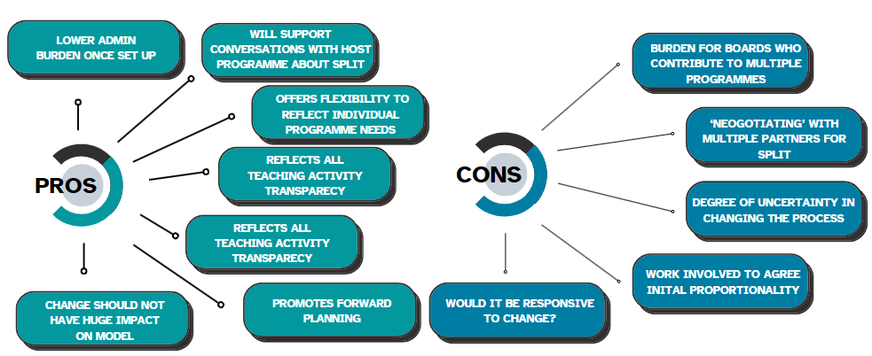
NEXT STEPS
- Based on feedback received at the event, Option 2 will not be pursued any further.
- The impacts of Option 1 and Option 3 will be carefully considered by NES, however it is expected that there will be no major change to the MoT process for the next cycle, which will be due for submission in late 2025.
- There will be an option for Boards to re-submit data from the 2024 MoT exercise for the 2025 MoT if so wished; NES will discuss this with the Medical ACT Officers who will support Boards with that process.
- It is anticipated that the earliest date for any changes to MoT will be made for Dec 2026 submission, in time for the 2027/28 financial year/model.

Topic 2: Major Investments (previously referred to as Capital Investments)
Laura Howard (NES Deputy Director of Finance) focused the session on how NHS Education for Scotland plans to manage and prioritise major investments for the financial year 2025–26, with the main aim of utilising the Medical ACT budget to its full potential.
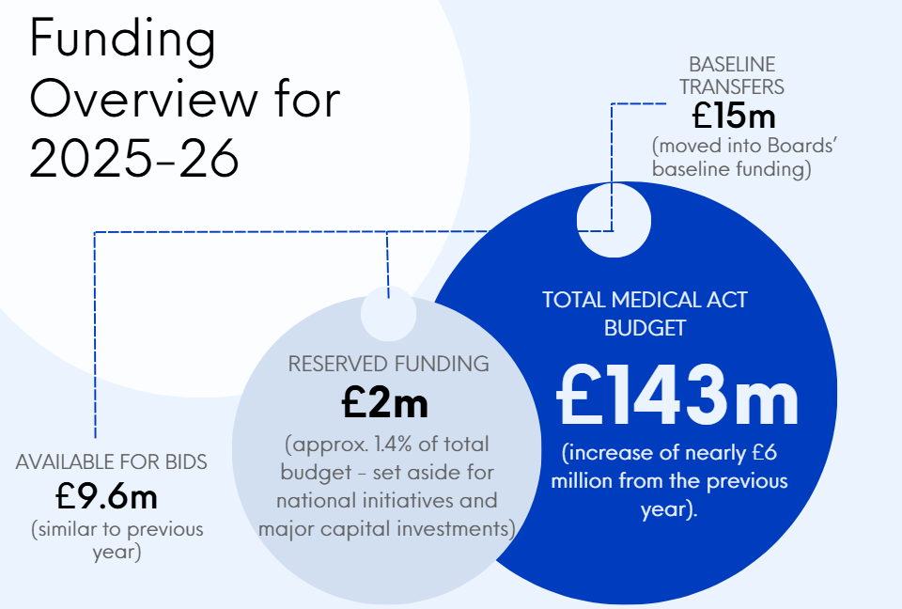

Major Investment Objectives
- Ensure full utilisation of the Medical ACT budget as NES is unable to carry forward unspent funds across financial years.
- Support infrastructure development to accommodate increased student numbers.
- Avoid underspend and return of funds to Scottish Government (£1,515,231 in 2023–24 and £3,250,823 in 2024–25).
- Boards are encouraged to submit Capital surveys to help NES plan over a 3–5 year horizon.
- NES will explore possible mechanisms to reserve funds across years for large-scale projects.
- NES will support NHS Boards with Revenue to Capital transfers where needed.

Major Investment Governance & Approval Process
Major Investment bids should now follow a three-tier approval structure, with distinct timelines for Boards to be aware of when bids are at a planning stage:
Bid Value | Approval Level | Time to Approve
Up to £250,000 | Monthly NES ACT Bids Meeting | Up to 1 month
£250,001 – £500,000 | NES Executive Medical Director & Director of Finance | Up to 2 months
£500,001 – £1 million | NES Chief Executive | Up to 3 months
Over £1 million | NES Board | 3 months +

There is still some work to be done to ensure that all Boards who require support in this way can access the available funding equitably.

NEXT STEPS
- Circulate a Capital Survey for 2025/26 for all Boards to complete (this will be sent alongside the Accountability Reports in May 2025)
- Develop Terms of Reference and establish a Major Investment Group.

Topic 3: Revised Travel & Accommodation Guidance
Alastair Campbell APGD presented this new draft guidance on behalf of NES.
- The current policy has been in operation since 2009, however changes to education delivery and growth in student numbers mean it has become outdated.
- In making revisions, feedback received via Medical ACT Officers and Regional ACT Working Groups was considered along with sustainability of the budget and an aim to achieve a “once for Scotland” approach. Both of these are important factors in, protecting the Medical ACT budget in the future when little growth is expected to occur.

What we heard from Stakeholders:
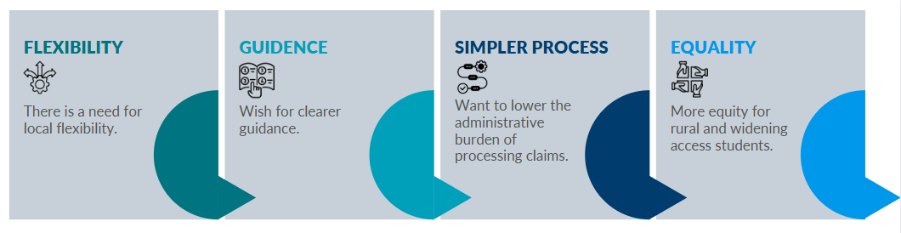
The main areas for update are outlined below:
- Removing the 5% cap on T, A&S spending.
- Standardising a mileage rate that will be supported by Medical ACT funding across Scotland; this will be set at 24p/mile, encouraging use of public transport and shared travel where appropriate.
- Clarifying eligibility criteria for claiming mileage; this will consider both the distance travelled and/or the time taken to do so (e.g., >20 miles or >30 minutes travel).

NES encourages Programmes and Boards to use the revised guidance, once it is released in final form, to review their local policies.

NEXT STEPS
- Amendments to the draft guidance will be made in response to stakeholder feedback.
- A final version of the guidance will progress via the NES internal governance routes.
- The revised guidance is expected to be available for implementation at the start of the new academic year 2025-26.

An Introduction to the ScotCOM MBChB Programme
We opened up the final session of the event to Dr Rebecca Walmsley, Programme Director for the new ScotCOM MB ChB programme based at the University of St Andrews. ScotCOM will welcome up to 55 students annually and will receive its first cohort of directly recruited students in September 2025. The programme is supported by 3 Partner NHS Boards: NHS Fife, NHS Borders and NHS Forth Valley. Unlike BSc students who transfer to partner Medical Programmes after 3 years in St Andrews, ScotCOM students will remain in St Andrews for their entire 5 years of study.
Dr Walmsley gave an overview of the programme, which is designed to:
- Produce doctors for Scotland, especially in hard-pressed specialties like general practice.
- Deliver a community-oriented, holistic curriculum.
- Embed students in community hospital hubs and primary care settings.
- Promote widening access and support for underrepresented students.
- Foster interdisciplinary, team-based learning.

Concluding Remarks
In closing the meeting, Professor Alan Denison, Lead Dean for Medical ACT commended the group on their collaborative approach within the discussions, which has allowed further progress to be made.
A further event will be arranged in Autumn 2025.

Appendix 1: List of Pros and Cons for MoT Option 1
Pros | Cons
Well established process that works. It's a complex area and any other model will have significant teething issues. | We spend more time gathering data that focussing on improvement
Established process | Very laborious / time consuming - in favour of changing system overall
Familiar process reflects real recent teaching, in place. | TOO BUREAUCRATIC AND COMPLICATED SORRY FOR CAPS!
Established system and recognises some (but not all) CAT B teaching | time consuming and labour intensive
Known - doesn't create uncertainty in process | too unwieldy, time consuming
Allows for more accurate results, as based on timetables rather than an "average" | Time consuming.  Uncertainty around consistent approach of data collection across all Regions.
Deep dive - gives significant granularity and can inform back to job plans - if feedback loop | complex
chance to review the number of Cat B activities | Time consuming, fluctuates annually,  high admin burden
Established process reflecting activities of both University and NHS | Significant labour involvement in collation.  Granularity does not link back easily to DME understanding of the high-level picture
Should be the default against which other options are measured. Be careful to ensure that any alternative is well thought through before implementation | Experience different approaches across programmes with information shared about placements to support sign off of MOT data
System in place and ACT officer's familiar | Complex and opaque. for those new to the process a lot of learning required
Established and familiar system (if not welcomed by all!) | Not consistent across Boards
understood, and matches what we deliver by "default".  Responds to change and development, or has done | Too complex and labour extensive.
 | ACT proportion by programme liable to change - despite stable activity
Labour-intensive data collection process
Retrospective nature means funding lags behind actual teaching delivery
May not be responsive to rapid changes in teaching needs
Complexity in calculating and verifying the data

Appendix 2: List of Pros and Cons for MoT Option 2
Pros | Cons
Data is easiest to collate | Will lead to volatility with funding and could represent a major risk for medical education with it not being funded appropriately
Simpler model, easier to track, less admin | Not an accurate reflection
Seems simple if the agreed % was adhered to | With student numbers increasing it is extremely important that cat b is recognised
more straight forward | impact negatively on boards that provide more cat b teaching
Similar approach already adopted in North region for Cat A only which works well and aims to ensure stability with funding | does not recognise Cat B
simple to use | Misrepresents overall teaching activity
Would benefit the co-located boards | How would this model capture student changes e.g. moving student back to co0located board for support reasons and not replacing with another student-
Simple | Wide variance in proportions of Cat A/B and need to make sure the proportions were consistent year on year
Simpler and quicker to compile
Potential stability for board planning with anticipated proportion - has worked well i north in recent years | Zero recognition of Cat B teaching and contribution by our faculty, including the increasing ask for clinical skills and simulation
Straightforward | To give an unbalanced financial allocation.  St Andrews Cat A profile will change going forward also. I wouldn't want a fixed allocation for a 3-year spell in a period of growth in a programme
Much more simple to cect but how would you deal with teaching weeks, induction blocks, remote teaching etc? | Too simplistic
Simple but.... | concern that Cat B activity undervalued / not accounted for
Easier (but much blunter) | Not fair as Cat B delivery split is totally different than Cat A week split.
would avoid potential for double counting | Ignores Category B teaching activities, which represent significant teaching effort  May disadvantage Boards that provide more intensive teaching with fewer student weeks  Could create disputes about agreeing on "fair" proportions  May not accurately reflect the true cost of teaching delivery
 | Would be detrimental to St Andrews teaching in Fife as Y2 and Y3 is completely Cat B
 | That detail will be lost in terms of delivered activity
 | Will cause a 2m drop in Tayside's allocation so not very attractive!
 | Unsure if this approach would still be gathering data retrospectively i.e. 2024-25 data to inform 2026-27 funding
 | Loss of accuracy. Loss of cat B data capture.
Student weeks removes our student-centred approach.
The week counts quantity not quality and misses out blended learning opportunities. Think we do need to include Cat B.
Think using student weeks alone is why we struggle with transparency.
These vary as the students' progress through the curriculum.
 | Ignores cat B may be inequitable depending of delivery style of teaching in Boards. Some Cat B is increasingly similar to Cat A - virtual teaching from live surgeries etc
 | Clearly a blunt tool and doesn't capture the "early years"" activity and contribution from Board to "cat B" work
 | How does it work for early yrs teaching, as a non co located board would need to understand this in much more detail
 | Maybe oversimplified now as programmes are diverse and not all using this model of sending students somewhere for a week or several weeks
 | Does not recognise cat b teaching. Oversimplified approach

Appendix 3: List of Pros and Cons for MoT Option 3
Pros | Cons
Is like current model but simpler | Its a really complex area and this may be too simple an approach
process need work out but should be simpler, allow flexibility for programmes/Boards and ability to plan long-term | Any new process is likely to cause years of teething issues, which may end up creating more work
Seems to be popular. Wont result in too big an allocation change. | More complex than option 2.
Offers flexibility to reflect individual programme needs, while not presenting a significant change | Challenging if frequent change (there has been in the last few years). Needs upfront agreement. May deter mid cycle change. A better middle ground with structure and fairness.
Reflects all teaching, reduces yearly workload, encourages collaboration through regional SOPS | Would it be responsive to change. if fixed for 3-5 yrs. how would a board increase their role, would need ,mechanisms
Continues to provide detail and acknowledges the various Cat B contributions | Need to ensure the data capture of Cat A and Cat B activities is accurate.
Most similar to current arrangement. | Burden for boards who contribute to multiple programs, "negotiating" with multiple partners for split of A / B and governance
A fairer method of distribution and recognition of CAT B | Degree of uncertainty in changing the process - and need more detail on implementation
Will drive/support a conversation with host programme about the planned split - planned and transparent | If % is based om historic results, then could lose track with a more simplistic high-level approach. Will need significant discussions with me ed teams and uni to ensure \% and %split are fair and reflective. How do you ensure consistent approach across the country
Seems to be a fairer approach and not having to gather Cat B data will be much less time consuming | Will impact on boards who have less opportunity to provide cat b
Probably in favour - seems a compromise re simplicity but accuracy - however need to understand it more. NB Needs to ensure allows for single placement days rather than placement weeks. | Remains complex to an extent
Might be an easier transition | Option 3 would need to ensure there is no cross over between CAT A & CAT B i.e. double counting as discussed earlier in meeting
Probably the fairest and least massive change to what we are used to doing | Proportion of cat B teaching asked for is dynamic depending on contractual arrangements of staff uni vs NHS
More comprehensive than Option 2 since includes both teaching categories  Maintains recognition of different types of teaching activities  Forward-looking rather than retrospective  Provides more holistic view of teaching contribution? | New process would need in depth review to understand the impact and changes required at Board level
Offers a potentially balanced approach and vehicle to develop transparent processes | Could create incentives to focus on quantity over quality of teaching
Favourite option. Includes all teaching (Cat (A&B). Remain student focused.  Governance for teaching and its delivery. Encourages dialogue between Programmes and HBoards which I think we do well. Appreciate the facts from the split and % thereafter. Interesting to see how this develops as students' progress through the curriculum vs differences between different programmes.  Aware of co-located boards and differences found - nice to explore these options.  Need governance plans and cycles.  Simplify Cat B choices - link to workable/summary teaching events | Will only add value if the cat B categories are simplified massively or just reduced to 1 ie student focussed activity +/- trainer CPD
This is more subtle approach to allocation, will allow account to be taken of CatB teaching which is central to some courses now; but remains more simple than current system | This option would again require some insights into what Cat B activity is and that it is separate from Cat A ie we need operational definitions
Similar to current model but hopefully without the administrative burden.

