
ST1 Starter Pack
Paediatrics
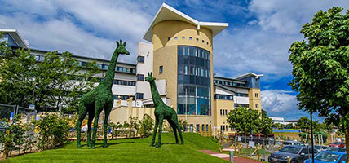
North of Scotland


Welcome to paediatric training in the North of Scotland!

We hope that you have a fantastic time during your training here!
This is a brief guide aimed at new paediatric trainees, so they know what to expect in the first few months of training.

Contents

- Brief overview of structure of training in North of Scotland
- ST1
- Things to do in Aberdeen and beyond
- Useful contacts

Structure of training in North of Scotland

Please be aware that Shape of Training is soon to be introduced and this will result in a change to the structure of your training – please see information contained within the Training Resources folder

You will begin your training in Aberdeen, either in the neonatal unit (Aberdeen Maternity Hospital, AMH) or in the children’s hospital (Royal Aberdeen Children’s Hospital, RACH). These are both at the Foresterhill site in Aberdeen.
You will complete 6 month rotations in both of these specialties in your first year.
Usually, ST2 and ST3 training is also completed in Aberdeen.
In ST4 and ST5, you will begin to rotate around other specialties, such as community, and you will complete minimum 6 months of your training in Inverness (Raigmore hospital).
Finally, from ST6 onwards, your training will be more structured to your chosen subspecialty career but will mostly be completed in Aberdeen.
You will discuss your interests and career aspirations in your supervisor meetings, and the TPD (Training Programme Director) will also try to facilitate any additional training opportunities you may be interested in, such as research, a PHD, specialty experience i.e. 6 month rotation in PICU in Glasgow/Edinburgh. The earlier you can inform the TPD of your intended plans the easier it is for them to organise it, but don’t worry if you don’t know – lots of more senior trainees are still unsure!

ST1

- Induction
Depending on your previous experience, this may be a daunting time for you! The induction to paediatrics is very friendly and aims to equip you with the essential information you need for your first few shifts.
You will obtain your usernames and logins in the first few days and at your overall hospital induction.
For your general paediatric rotation, the handbook will detail your day to day duties on various shifts and the senior trainees will be able to answer any questions you have on what’s expected in any given area:
      - Quick overview summary!
- Paediatric Assessment Unit (PAU)
- Day Case Unit (DCU)
- Greenzone (GZ) and information on time-sensitive blood samples
- Haematology/oncology and survival guide
- Surgical ward
- Useful numbers for RACH
For your neonatal rotation, there is a comprehensive induction and the trainees and ANNPs will keep you right!

- What’s expected of you as an ST1
  - In neonates, you will spend time on the postnatal ward, HDU/SCBU and ITU. You will carry the junior bleep and attend deliveries and resuscitations. Try to complete your NRP (Neonatal Resuscitation Programme) course early on in your rotation – these are run in Aberdeen in the maternity hospital. You will be working closely with more senior trainees and consultants who will support you as you gain experience in the common neonatal presentations. In addition, you will gain experience in skills such as IV cannulation, venepuncture and lumbar punctures. There may be opportunities for more advanced skills including insertion of umbilical lines and intubation. Initially you are supernumery on nights, until you feel confident to attend deliveries alone.
  - In paediatrics, you will work in:
    - PAU - clerking patients, performing investigations and forming management plans – this is a great time to practice this as you have senior colleagues around you to give feedback on your plans. This is also a good place to complete work based assessment.
    - DCU - you will have a list of outpatients attending for investigations, usually bloods or a cannula, occasionally an examination, and a few inpatients who need clerked, cannulated, reviewed if indicated, and a discharge letter. It is your responsibility to chase blood results and act on these if necessary – this is covered in more detail in the handbook and at induction.
    - Medical ward – ward rounds, jobs, reviews etc.
    - Nights – in PAU.

- Supervisor
Get in touch with your allocated educational supervisor early on and arrange your first meeting. You will also have a clinical supervisor – this may be the same person as your educational supervisor. This is a good opportunity to discuss your aims for the year, for example, if you have particular interests, wish to gain experience in a certain skill, improve presenting skills – and they can help identify how you might achieve this.

- Gaining experience
There are lots of opportunities for learning other than during clinical work, including clinic days, trainee training days, simulation sessions (run by the surgical team) and lots of teaching from consultants, trainees, GP/FY doctors and specialist nurses. The departments are always keen for trainees to run teaching sessions, organise journal clubs and present critical appraisals and literature reviews so if you are interested let one of us know!
There are opportunities to join specialist clinics – these include haematology/oncology, child protection, community paediatrics, nephrology, rheumatology, cardiology, respiratory, surgical paediatrics and urology.

- Guidelines
There are guidelines for both paediatrics and neonatal medicine – see the intranet. Trainees will show you where exactly to locate them.
The BNF/neonatal formulary/pharmacist are very useful resources if in doubt!

- ePortfolio
You will also start using your ePortfolio (Kaizen, through the RCPCH website) at this time. Make sure you do a PDP (personal development plan) at the start of each rotation to guide your goals etc. Try to keep on top of it by updating it regularly with teaching events attended, skills obtained, assessments etc.

- TURAS
You will have access to TURAS, which is the system we use to apply for study leave. It also contains information about your rotations. Some of your employment forms will now be on TURAS and can be completed online.

- Study leave
You should ensure your rota coordinator is aware and has approved your request prior to applying, where possible. The request will be reviewed by the TPD and approved +/- funding. If you have applied for funding you will receive a form for requesting reimbursement.

- Paediatric Trainee website (https://www.paediatricsnos.com/)
The NoS paediatric committee has formed a website for both trainees and non-trainees to use.

Things to do in Aberdeen and beyond

- Socialising
There is a wide range of bars, pubs, clubs and restaurants to suit all tastes! Some bars do themed nights and weekly events such as salsa dancing and pub quiz!
- https://www.visitabdn.com/food-and-drink/
  - https://www.tripadvisor.co.uk/Restaurants-g186487-Aberdeen_Aberdeenshire_Scotland.html
  - http://www.aberdeenperformingarts.com/whats-on


We try to have a dinner or two per rotation so we can socialise outside work – again, we are always looking for people to organise socials!
There is an annual mess ball as well as plenty of impromptu get togethers. We have a paediatric trainee Whatsapp group, as well as groups for each 4/6 month rotation so no one gets excluded.

- Sport and the great outdoors
There are plenty of sports facilities, and some do a discount for NHS employees (free access to the Aberdeen Sports village off peak with your university card which you can apply for if you are teaching medical students).
There is a paediatric football team who play on Tuesday evenings.
There are hundreds of local walks and areas to explore including various parks and the beach.
- https://www.walkhighlands.co.uk/aberdeenshire/aberdeen.shtml
- https://www.walkhighlands.co.uk/aberdeenshire/
There are designated cycle pathways:
- https://www.aberdeencity.gov.uk/services/roads-transport-and-parking/cycling-aberdeen/cycling-maps
As well as mountain biking trails:
- https://www.trailforks.com/region/aberdeenshire/
Sailing, rock climbing, running...

- Beyond Aberdeen
  - Nearby Stonehaven is a lovely seaside town with Dunnottar castle nearby, icecream (Aunty Betty’s is famously good) and an outdoor heated swimming pool open in the summer.
  - There is a whole coastline of beautiful beaches and inland dramatic Grampian mountains and lochs to explore and enjoy on your days off....

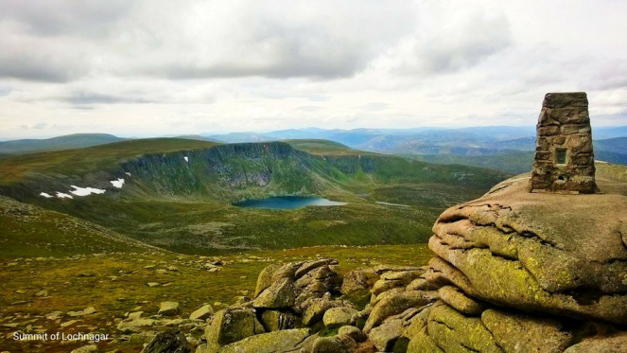

Useful contacts

- Kathryn Reid is the backbone of the department! She is the Medical Education Administrator and she can answer almost all of your questions in relation to paediatric training, and if she can’t she’ll point you in the right direction!
kathryn.reid@nhs.net
- The neonatal secretaries are Debra Bowie (debrabowie@nhs.net) and Susan Malanek (susan.malanek@nhs.net).
- Carol Leiper is our training programme administrator, based in Inverness:
carol.leiper@nes.scot.nhs.uk
- Our current TPD is Dr Shyla Kishore:
shyla.kishore@nhs.net
- Your NoS paediatric training committee are all approachable and friendly, based in Aberdeen and Inverness, and are here to bring the trainees together to make our training as great as possible!
Contact us on paedscommittee.northscot@nhs.net.
Your current committee is kept updated via the website and on posters dotted around – please feel free to approach any one of us!

We would love for new trainees to join our committee meetings and hope one day you will join the committee to influence and improve our training further!

- Your rota co-ordinators will introduce themselves prior to you commencing your rotation and can be contacted with leave requests, including study leave requests.

We look forward to welcoming you and working with you!

