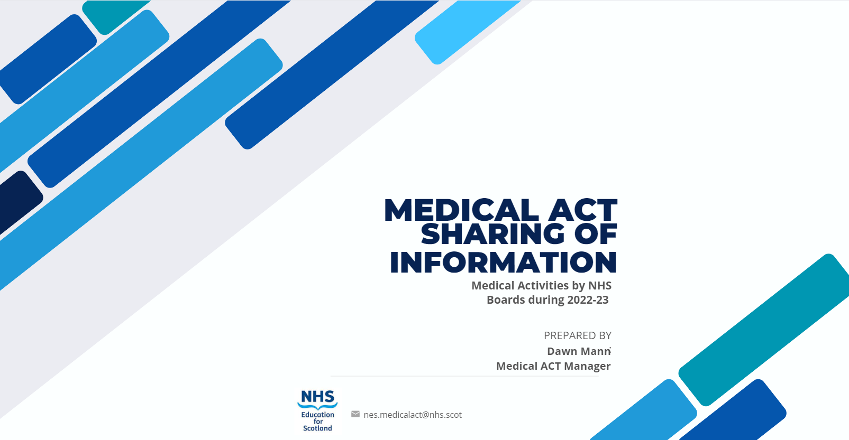

Contents
Foreward 2
Executive Summary 3
Challenges identified during 2022/23 4
Challenges anticipated for 2023/24 and beyond 4
Anticipated Changes to Undergraduate Teaching 4
Summary of Section 1 6
Section 2: Summary of Baseline Funding, Additional Allocations Funding and Slippage 6
Section 3: Extracts of Board Responses 8
3A: Local Governance Arrangements 9
3B: Sharing Intelligence around Medical ACT 13
3C: Challenges Past Year & Future Year 18
3D: Anticipated Changes to Undergraduate Teaching 20
3E: Barriers you have encountered to using full Medical ACT Additional Allocations 22

Foreword
All Health Boards in receipt of Medical ACT funding are required to submit an annual accountability report to NES; this includes all 14 territorial Health Boards, the State Hospital, Scottish Ambulance Service, National Waiting Times Centre and National Services Scotland (NSS), which reports on activity from the Scottish National Blood Transfusion Service (SNBTS).
This paper provides an overview of Medical ACT activities carried out by Health Boards between the start of April 2022 until the end of March 2023.
A central aim of this paper is to share and showcase the learning, innovation and expertise that Medical ACT funding has supported in Scotland’s NHS, but also highlight the future challenges and opportunities that exist in the clinical education of medical students. This information is contained in Section 3B – 3E and illustrates the richness, breadth and depth of activity that has been delivered during a period of evolving and challenging circumstances in the NHS.
We would be pleased to receive any comments relating to the content of this summary paper, which may be submitted to the following address: nes.medicalact@nhs.scot.



Executive Summary
The deadline for Health Boards to submit accountability reports in this cycle was 22nd September 2023; 14 out of 18 Boards submitted their reports in advance of this date; a report submitted on behalf of Boards aligned to the ScotGEM programme was also received within the deadline. At the time of producing this paper, accountability reports have been submitted from 17 of 18 Boards.

Local Medical ACT Governance Arrangements
Section 3A of the Accountability Report relates to information which has been provided by Boards in respect of their local governance arrangements for Medical ACT funding. The attached table provides a summary of the information submitted.
With the exception of some smaller Boards, most have a formalised local ACT working group (LAWG) or an equivalent structure to discuss Medical ACT matters. It was helpful that some Boards included information on how Medical ACT feeds through governance structures to the Board.
The following are suggested as examples of good reporting of a Board’s local governance arrangements:
- Shetland has Medical ACT as a standing agenda item as part of its Medical educational governance group which is attended by the Medical Director.
- Lothian provided a helpful governance organisational chart.
- Highland-Medical ACT budget is discussed at the Medical Education Governance Committee, which meets quarterly.
- Grampian reported that the DME attends the Medical & Dental Education Governance Group which through Staff Governance Committee to the Board.
- Ayrshire and Arran’s Medical Education Governance Group is co-chaired by a non-executive Director and DME.

Sharing Intelligence
Medical ACT funding was used to support a wide-ranging set of proposals during 2022/23. Boards were invited to provide details of proposals which they had submitted during the reporting period which they considered as examples of innovative practice worthy of sharing.
The following have been highlighted as innovative initiatives:
- Dumfries and Galloway have devised and implemented two medical escape rooms, which have proved popular with students as an immersive and engaging learning experience.
- Tayside is part of a ‘Student Led GP Clinic’ project which triages patients to be assessed by undergraduate medical students within a GP clinic under the supervision of a GP.

Challenges identified during 2022/23 and Challenges anticipated for 2023/24 and beyond.
The information provided for Sections 3C and 3E was used to identify and highlight common themes. It is clear from the information provided that the impact of increasing student numbers is still an ongoing concern across Health Boards.

Anticipated Changes to Undergraduate Teaching
Many universities have undertaken reviews of their curricula which has required Boards to implement changes; the impact has also been driven by an increased number of students in the system. Section 3D of this document provides information of these changes indicated by the Boards.

Recommendations
NES proposes the following changes for the Accountability Reporting Template and Process for 2023/24:
- NES will continue to pre-populate available information for Sections 1, 2 etc. but will add new column for Boards to provide updates where necessary, so that any changes made are visible.

- There will be a new section requesting that Boards provide an Organisational Chart for their Medical Education structures; this will be retained and re-populated in future reports.

- More detailed information on why bids were not implemented fully will be sought; this will be in the form of drop-down menus to help with completion.

- Learning from Accountability Reporting is currently shared with stakeholders via a feedback paper from NES; future templates will include a section for Boards to provide their views on how to improve efforts to share intelligence across the regions.

- NES is considering the feasibility of simplifying the information requested within Section 3C; any changes for potential implementation during the 23/24 reporting cycle will be fully discussed with representatives from the Scottish DME group and Medical ACT Officers before new templates are issued in May 2024.

Introduction
NES was able to account for 99% of all Medical ACT funding received by Boards during the 2021/22 accountability reporting process, which was the highest ever level of accountability achieved. Due to this success, only minor changes to the accountability reporting template were made in advance of the 2022/23 exercise.
Changes included:
- The report was split into an excel format which was designed to support reporting of financial information and a Word format for the written elements. It was hoped these arrangements would make it easier to write commentary for Section 3 and allow for easier completion by Finance and DME teams.
- Following work by stakeholders to complete Section 2c – Baseline Spend last year, NES has pre-populated this section with known information.
- An additional Tab was added (2d) to capture information on Clinical Teaching Fellows (or equivalent) within Boards including the percentage of time spent on teaching activities.
- An additional question was asked to highlight any barriers to Boards using their Medical ACT additional allocations funding, Boards are expected to create bids for new educational activities for submission to NES.
As in previous years, all reports were required to be presented at the appropriate Regional ACT Working Group, for review and discussion of their content, prior to being formally submitted to NES.

Summary of Section 1
Boards were asked to submit accountability reports by 22 September 2023. 14 out of 18 Boards submitted their reports in advance of this date; a report submitted on behalf of Boards aligned to the ScotGEM programme was also received within the deadline. At the time of producing this paper, accountability reports have been submitted from 17 of 18 Boards.

Section 2: Summary of Baseline Funding, Additional Allocations Funding and Slippage

2022/23 Final allocation with funding requiring bids
 | Recurrent allocation | Non recurrent allocation | Total allocation | Previously approved recurrent baseline | Funding requiring bids*
Ayrshire & Arran | 3,878,498 | 84,098 | 3,962,595 | 3,400,678 | 561,917
Borders | 795,937 | 15,568 | 811,504 | 795,937 | 15,568
Dumfries & Galloway | 877,129 | 20,237 | 897,366 | 875,508 | 21,858
Fife | 3,840,583 | 479,200 | 4,319,783 | 3,393,339 | 926,444
Forth Valley | 1,534,787 | 32,811 | 1,567,599 | 1,529,529 | 38,069
Grampian | 16,949,741 | 118,303 | 17,068,044 | 14,535,433 | 2,532,611
Greater Glasgow | 20,901,584 | 465,454 | 21,367,038 | 20,694,048 | 672,991
Highland | 4,629,596 | 36,912 | 4,666,508 | 4,351,221 | 315,287
Lanarkshire | 4,690,416 | 105,359 | 4,795,775 | 3,771,915 | 1,023,860
Lothian | 20,166,496 | 415,697 | 20,582,192 | 19,722,654 | 859,539
Orkney | 109,452 | 646 | 110,098 | 62,866 | 47,232
Shetland | 191,579 | 7,713 | 199,292 | 162,684 | 36,608
Tayside | 16,135,968 | 436,048 | 16,572,016 | 13,797,310 | 2,774,706
Western Isles | 219,248 | 1,211 | 220,460 | 218,733 | 1,727
NSS SNBTS | 26,741 | 327 | 27,068 | 26,741 | 327
State Hospital | 33,555 | 313 | 33,868 | 33,550 | 318
Ambulance Service | 17,222 | 2,693 | 19,916 | 4,137 | 15,779
The National Waiting Times Centre | 791,230 | 19,910 | 811,140 | 496,410 | 314,730
Total | 95,789,762 | 2,242,500 | 98,032,262 | 87,872,693 | 10,159,569

The total Medical ACT funding available for distribution within the allocation model for 2022/23 was £98.0m; this represents an increase of £6.5m from 2021/22 levels. In addition, the ScotGEM and Edinburgh HCP-Med programmes received an increase of £0.2m and £0.5m respectively, bringing the total funding of these programme to £4.6m and £1.1m; and the total funding distributed through Medical ACT to £103.7m. Funding unutilised in year was 0.1m, representing <0.1%of the annual budget.

The following information was highlighted through analysis data provided by Health Boards in section 2 of the Accountability reports.

Bids Trends
There was approximately £10m available for additional bids from Health Boards; 394 bids received, 3 times more than in 2021/22, reflecting the 350 increase in medical student numbers and subsequent funding in the system.​
Of these bids:
- 156 were for posts.
- 136 were for equipment.
- 25 were for infrastructure/accommodation.
- 77 miscellaneous.

Slippage Data
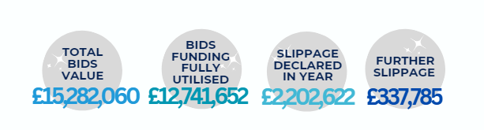
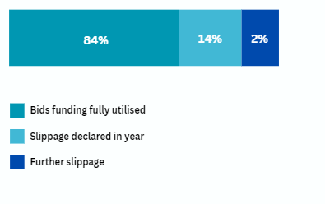

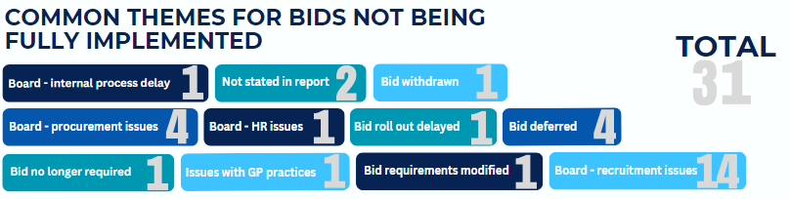

Section 3: Extracts of Board Responses
In section 3A Boards were asked to provide an overview of the Medical ACT Governance arrangements they have in place, including details of the interface between local groups, regional Medical ACT groups and up to Board level.

3A: Local Governance Arrangements
Health Board | Local Governance Arrangements
NHS Ayrshire & Arran | - Medical ACT is within the business of Medical Education Governance Group.  - Co-chaired by a non-executive Director and DME.  - DME chairs Training Quality Management Groups for each specialty/department with remit of Medical ACT and undergraduate teaching included.  - Meets four times per year.
NHS Borders | - Local Medical ACT Meetings occur, frequency not specified.  - Proposals discussed within Medical Education Team initially.  - Proposals then brought to the Board through the DME for approval.  - If DME is unable to attend a meeting, chairing is delegated to ADME.  - Finance representative and Medical Education Manager will liaise to ensure the presence of one or the other.
NHS Dumfries & Galloway | - Education Committee meets quarterly, and Medical ACT is a standing item on the agenda.  - Medical ACT funding is discussed at the meetings with Hospital subdean, DME, Education Centre Manager and Finance representation.
NHS Forth Valley | - The Board does not hold local Medical ACT Meetings; however Medical ACT issues are captured in the regular Undergraduate meetings within the Medical Education Department.  - Medical ACT in NHS Forth Valley follows the governance structure of the Regional ACT Group.  - DME or Deputy DME, lead Administrator for Undergraduate services and a Finance representative attend the West RAWG meetings.
NHS Grampian | - Has a Local Medical ACT Working Group (LAWG), usually meets 3 times per year in full membership.  - LAWG agrees Grampian’s full budget and proposals for additional allocations.  - Monthly meetings between Medical ACT Manager, NHSG Senior Finance Manager and Undergraduate DME.  - Regular meetings held every 1-2 months between the Medical School’s curriculum team, NHS Grampian management, Undergraduate DME, Medical Education Quality manager and Medical ACT Manager.  - Tutelage committee remit includes the governance of clinical teaching.  - The DME attends Grampian’s Medical & Dental Education Governance Group which reports through Staff Governance Committee to the Board.
NHS Greater Glasgow & Clyde | - Medical ACT issues discussed locally as part of regular meetings.  - Represented at Board Medical Education and Staff Governance Group.  - Attended by DME, Medical Director, Deputy Medical Director, Finance Colleagues, UoG Medical Schools lead and Regional Medical ACT Manager.  - DME reports to the Board Staff Governance Committee bi-annual meeting.  - NHS Greater Glasgow and Clyde have consistent engagement with and representation at Regional ACT Working Groups.
NHS Highland | - Regular Medical ACT budget meetings between DME, Finance and Medical Education Quality Manager.  - Local Medical ACT Meetings take place to discuss proposals with representation from DME, Medical Education Quality Manager, Clinical Skills rep and Teaching Fellow.  - Medical ACT budget discussed at NHS Highland’s Medical Education Governance Committee, which meets quarterly.  - Medical ACT spend is reported through the Highland and Islands University of Aberdeen Tutelage meeting.  - Combined Undergraduate and Postgraduate Governance Meetings are held within directorates.  - Bids for funding are reviewed within the Board by a small committee consisting of DME/UG DME, Medical Education Service Manager, University representative, Teaching Fellow and those with local approval will be submitted to RAWG.
NHS Lanarkshire | - Medical ACT is discussed at Medical Education Governance Group (MEGG) and has representation from DDME for Undergraduate and the Lead Dean/Head of Medical School from main partner university.  - At management meetings within the Medical Education Department, with Medical ACT bids and reconciliation as an agenda item.  - DME meets with the Deputy Director of Finance who leads on Medical ACT approx. 4 times a year.  - DME through department management meetings and 1:1 meeting with Undergraduate Senior Team develops the bids which are then developed with the Deputy Director of Finance and Medical Education Manager.  - The delivery and quality management are formally reviewed and reported by Medical Education Governance group. MEGG is co-chaired by the DME and Medical Director of the Acute Division and reports to the Quality Planning and professional Governance group which reports to the NHS Board.  - DME reports to Executive Medical Director with regular 4-6 weekly 1:1 meetings, where ACT is discussed as required and appropriate.
NHS Lothian | - DME is the Regional ACT chair with additional representation from Finance and post holders in Edinburgh MBChB. Deputies will be sourced if required.  - The Lothian DME and Undergraduate leads are involved in year committee meetings and the MBChB Programme Committee held up to four times a year.  - The Lothian DME and Service manager meet with the NHS Lothian Finance lead for ACT (and R&D) monthly.  - The Lothian lead has regular meetings with the UoE ACT officer, and all 4 members meet prior to each Regional ACT meeting (3 times/year) usually with the MBChB programme director prior to the allocation meeting in June or September.  - A helpful Governance structure diagram was provided.
NHS Orkney | - Medical ACT discussions are held within the Medical Education Governance (MEG) Group meetings.  - MEG group includes DME, deputy educational leads, and invitations to primary and secondary care trainers, Finance Officer and HR.  - Liaise directly with Medical ACT Officer as required.  - Regular attendance at North RAWG meetings.
NHS Shetland | - NHS Shetland has a Medical Education Governance Group (MEGG), which is chaired by the DME and is held monthly with representation from finance, Medical Director and Director of Acute Services.  - Medical ACT is a standing agenda item.  - The MEGG is part of NHS Shetlands governance structure. The Director of Medical Education’s annual report forms part of the Medical Director’s report to the Board.  - Minutes and actions are fed into Joint Governance Group, which reports to the Clinical Care and Professional Governance Committee (CCPGC).  - The CCPGC reports to the Integrated Joint Board and NHS Shetland Board.  - DME sits on all groups and feeds Medical ACT related business both ways
NHS Tayside | - Local ACT meetings occur about four times per calendar year and are usually held two weeks in advance of the scheduled RAWG meetings.  - Chaired by the DME, and attended by a Deputy DME, an Associate DME, Medical Education Manager, ACT Officer, Medical Education Co-Ordinator, and various University of Dundee representatives.  - All bids are reviewed and refined by the ACT Officer before being submitted to the Local ACT meeting, where they are scrutinised and reviewed before being approved as appropriate.  - Once approved all new bids are then submitted to NES for review, prior to the next Regional ACT Working Group where the bids will be formally discussed, and formal approval decisions then made by NES.
NHS Western Isles | - A small and close-knit unit, NHS Western Isles does not have a formal Local Medical ACT Working Group.  - Close links between the DME and Finance re Medical ACT matters, ably supported by the Medical Education Co-Ordinator.  - This functional structure continues following changes in personnel within the fields of both finance and medical education.  - There are ongoing ad hoc discussions involving the DME, clinical skills team and medical staffing, along with senior medical management (particularly the Medical Director), with respect to what the undergraduates need, relating to what the Universities expect of us and what we aspire to deliver/provide.
ScotGEM | - ScotGEM RAWG meetings are chaired by the NHS Dumfries and Galloway DME and are attended by representatives from the 4 Boards, 2 Universities and NES.  - Professor Dowell retired as Programme Director in March 2023.  - RAWGs attended by clinical and managerial representatives from the four Boards, the two Universities and NES.  - In addition to this there are a number of regular formal meetings including Programme Board, Curriculum Meeting, DME and DME and Finance leads.
The Scottish Ambulance Service | - No local Medical ACT meetings are held.  - Discussions are held with the Associate Director of Education and Professional Development.
The State Hospital | - Meetings are held on an as required basis.  - Medical ACT forms part of reports on Medical Education to the Board.

3B: Sharing Intelligence around Medical ACT
In section 3B Health Boards were asked to provide details of any innovative Medical ACT funded activities and initiatives which have been beneficial and which they felt could be beneficial and potentially transferrable to other Boards. The collated responses are below.
Health Board | Intelligence to share around Medical ACT
NHS Ayrshire & Arran | - Appointment of a GP with funded time to support undergraduate medical education within the acute setting has helped bridge learning experience for students and knowledge/understanding of relationships and pathways between primary and secondary care.  - Similar to the previous year investment in additional residential accommodation to increase student accommodation alongside payment of increased travel expenses has allowed the board to increase capacity to host more students.  - In emergency medicine self-rostering seems to have been a success and helps ensure not too many students on at once are competing for same practical skills/ procedures/ patients.  - Four 4-bedroom townhouses have been purchased by NHS Ayrshire and Arran in a new build development (Scholars) in central Kilmarnock. Three of the houses were purchased with ACT funding, the fourth house was purchased with funding from the Board. In addition to the purchase price there were associated costs for repurposing layout to make them suitable for students and costs for floor furnishing (including flooring and appliances). These costs were mainly funded by the Board.  - The accommodation was purchased for the primary and sole purpose of enabling support of medical student expansion, allowing the Board to accept more students.
NHS Dumfries & Galloway | - Have devised and implemented two medical escape rooms, which have proved popular with students as an immersive and engaging learning experience. This has since been published in The Clinical Teacher with Katie Percival and Sarah Snow (both previous CTFs) as lead authors.  - Article can be accessed via this link: http://doi.org/10.1111/tct.13578  - Active travel promoted to students by providing bikes (funded by Medical ACT) for them to use while on placement and a comprehensive induction to ensure safe use.
NHS Fife | - An additional undergraduate coordinator has built resilience into the existing team meaning new projects can be carried out e.g., liaising with Digital & Information to ensure all students are given access to clinical systems, and continuing/developing Widening Participation activity including a second successful year of the Experience Medicine Summer Programme.  - Recruited additional teaching staff from multi-disciplinary backgrounds to help increase capacity for learning. Staff include Clinical Educators who come from a nursing background, specifically ICU and Resuscitation teams, and Clinical Physiologists in Cardiology. These teachers help to increase capacity for year 2 and 3 St Andrews BSc teaching.
NHS Forth Valley | - Multidisciplinary Undergraduate Simulation mapped to FY1/FY2 related Datix/adverse incident reporting systems to share learning and prevent recurrence of events.  - Ongoing Psychology sessions to support wellbeing at work and looking after yourself as a medical professional.
NHS Grampian | - Clinical Teaching Fellow posts (not a new proposal but a long-standing arrangement).  - Consultant sessions in clinical departments to create the required growth in clinical teaching capacity.  - Clinical Tutors, Educators, Facilitators.  - Staff and equipment for teaching in a simulated clinical environment.
NHS Greater Glasgow & Clyde | - Have purchased a range of equipment / kit to support student teaching, including:  - Airway trainers to support the increase in number of students within Anesthetics as a result of this introduction to the curriculum.  - Knee and Shoulder Aspiration and Injection Trainers – to support teaching within rheumatology.  - Age Simulation / Frailty Suit - to create the experience of old age thereby allowing. students the opportunity to experience the impairments of older people.  - Progressing a project to implement a 3D data platform which will enable professional level 360-degree virtual tours, with the aim of enabling a better grasp of site/department layouts in addition to insight into how the hospital works, patient flow routes etc.  - have appointed a simulation lead for Paediatrics, to develop and deliver simulation activities which are delivered within NHSGGC for NHS Lanarkshire and NHS Ayrshire and Arran in addition to NHSGGC.  - Further Simulation Nurse Educators were appointed to lead and support the development of undergraduate simulation training/activity within NHSGGC. The educators support the main UG courses - RMSP; 5EM (Emergency Medicine); Child Health and O&G; and the addition of mental health nurse educators will support the development of undergraduate psychiatry simulation training/activity within NHSGGC and across WoS.  - Professional actors have been utilised, to support psychiatry simulation by recreating realistic scenarios for teaching and learning purposes.  - Virtual reality headsets were purchased to create a mixed reality environment, generated using patients' scans showing true pathologies, where the students are able to understand the relationship between brain lesions and patients' clinical presentation.  - Simulation model equipment was purchased to increase student appreciation of neurosurgical conditions and provide the opportunity to simulate their management.
NHS Highland | - Establishment of a student discretionary fund has been a positive step. Evaluation within the 22/23 financial year has not been possible due to late notice/recognition of approval, however in the early months of FY 23/24 we have already seen the benefit of this in supporting students who are disadvantaged by rotation to NHSH through losing access to regular Employment and therefore running into financial difficulty.  - In 21/22 we appointed an ACT funded Board lead for Student support. This role has proved invaluable since appointment, providing a local route for support and signposting to the University student support services, but also working closely with the University student support lead to develop local processes and staff training.
NHS Lanarkshire | - Quality Improvement Project manager  To allow us to improve the delivery and QI cycle documentation of our current UG teaching quality improvement and pilot the postgraduate SMART objectives within Board.  - Following the project, we have employed a Band 7 Quality Improvement Manager. This post is being supported with colleagues in Quality Assurance and Clinical Governance at Board level, and are co-hosting the post, although they are wholly employed by medical education and workstreams are only from our department. This would ensure that the person undertaking the role would be embedded in Quality Assurance systems for the board and maximize the opportunities that this would offer.  - GP simulation teaching and courses have continued to be developed. These are being shared with colleagues from Glasgow University. The GP Fellow has been involved in developing and delivering the below GP simulation project for 2022/23.  - A GP simulation pilot aimed at 3rd year undergraduate medical students was delivered by GP fellow, senior clinical skills specialist and GP clinical lead trainer. There was a total of 11 half-day sessions. A total of 40 students attended across these sessions. The Feedback was positive, interestingly the majority were considering a career in Primary care. The session saw a significant increase in confidence scores across acute skills and management, situational; awareness, coping with stress and decision making. The next steps are GP fellow taking the lead; aiming to publish an article on the student engagement with GP simulation. We are currently in conversation with University of Glasgow to deliver across the year.  - The CTF in Professionalism post has afforded the opportunity to teach all stages of the undergraduate curriculum at University of Glasgow and to develop a suite of teaching materials relevant to other medical students.  - The professionalism academic workstream has significantly benefitted from the CTF role. Work to date has included projects benchmarking professionalism attainment during undergraduate medical school; a literature review concerning how students learn professionalism; co-facilitating numerous workshops for clinical staff about optimising the learning environment to teach professionalism; substantial contributions towards several national and international events including administrative faculty roles, oral and poster presentations.  - Internal systems have been developed for Medical ACT and MoT and based on NHSGGC tariff tools and our own refinements to ensure we can accurately describe the teaching done in a department in a format that allows and facilitates us to work with Clinical leads to ensure this is reflected in job plans and can be tracked (on going).  - We have worked extensively with clinical leads this year and this is allowing us to manage increased undergraduate numbers and aim to maintain teaching quality. The teaching time in job plan will be clearly identified in Trainer’s job plans, allowing it to be identified, protected and offer the individual recognition of this role.
NHS Lothian | - Simulation for capacity building: Benefits of Simulation teaching techniques have been shared amongst the different NHS Boards across the Edinburgh Region with most having introduced their own suites.  - Changes to the Edinburgh MBChB especially in Year 4, have been discussed at various meetings such as RAWG and changes made to build capacity and enhance the student experience.  - As above, we are using simulation to enhance student capacity – this includes the use of language simulators to prepare for “real” interactions.  - We are also building spaces in our Outpatient and mental health settings to leverage capacity through linked student spaces to outpatient clinics (Aberdeen/Grampian model).
NHS Shetland | - The Clinical Development fellow (whose development time is funded by Medical ACT) has undertaken a scoping exercise to help understand the challenges of primary care hosting medical students.  - This work has led to helpful conversations on how to help support primary care better in terms of teaching and training. The information has resulted in a redesign of the medical student placements both in secondary and primary care with a joined up teaching and learning week to be hosted once per block.  - This model of teaching provision has been shared with the University of Aberdeen medical school who have been supportive in a test of change. The model may be applicable to other remote and rural local education providers.
NHS Tayside | - Newfield Student Led GP Clinic – This pilot project triages patients to be assessed by undergraduate medical students within a GP clinic environment, under the supervision of a GP. Four students are able to be supervised at one time, increasing teaching capacity for GP student placements. The premises costs were funded directly by the Scottish Government and review and assessment of the project are ongoing by University of Dundee. Equipment used in the clinic was Medical ACT funded.  - Clinical Skills Virtual Reality Centre – this is Scotland’s first facility which offers students and staff the opportunity to experience different virtual environments and situations.
NHS Western Isles | - Recently introduced Pagers for students to support them attending educational events. The new facility has been well received and students have already commented positively about enhanced clinical experience.  - The pagers will also feature in the programme of a simulation scenario day, which is provisionally planned for September 2023.
ScotGEM | - The General Clinical Mentor (GCM) sessions are an innovative way of delivering support, guidance and teaching to students in a small group setting across each year group. Dundee Medical school has based its Integrated Teachers upon the GCM model.  - It should be noted that £228k of year-end underspend was transferred to Dundee University to fund a joint programme of evaluation and research with the agreement of NES and the RAWG. Further details are currently being developed.

3C: Challenges Past Year & Future Year
In section 3C Health Boards were asked to provide details of any anticipated challenges which may impact the delivery of Undergraduate Medical Education in the Board and an overview of any issues that prevented them using their full Medical ACT allocation. We have used the answers provided to produce the below common themes.
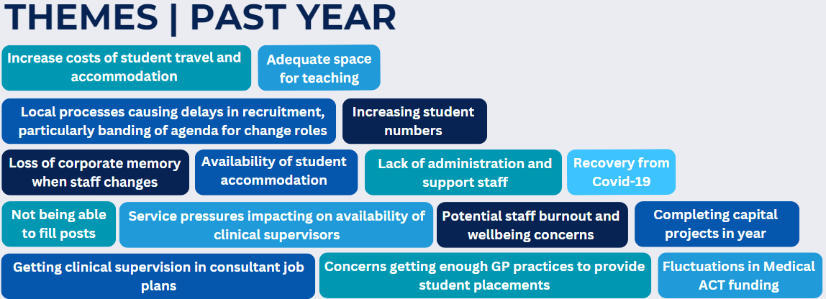
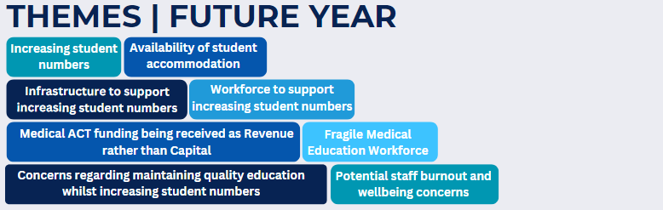
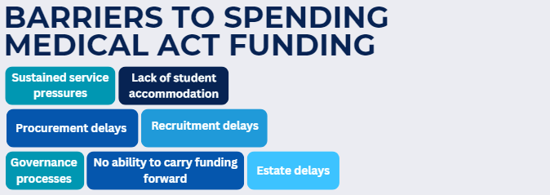

3D: Anticipated Changes to Undergraduate Teaching
In section 3D Health Boards were asked to provide details of any known changes to Undergraduate teaching or curriculum which could impact Medical ACT. The table below lists information provided from Boards of confirmed changes and those currently under review/consideration.

Health Board | Confirmed Changes | Review/Considered changes
NHS Ayrshire & Arran | Reconfiguration of critical care services with concentration of Level 3 beds on the Crosshouse site. This is unlikely to impact significantly as we already schedule critical care teaching on the Crosshouse site for 50% of the Year 4 medical students at Ayr.
NHS Grampian | GP Year 4 placements: After a pilot in 22/23 academic year, placement duration has increased from 4 weeks to 5 on recurring basis in 2023/24 academic year, (We are also proposing to pilot a move to 6 weeks in some selected practices and blocks in 23/24).
NHS Grampian |  | Secondary care clinical teaching: move within NHS Grampian to have more staff engaged in face-to-face teaching.
NHS Grampian |  | Increase in simulation training to augment to prepare students for, and get maximum out of, clinical placements.
NHS Greater Glasgow & Clyde |  | Creation of new specialty blocks and expansion of existing blocks are being considered to mitigate the impact of rising student numbers; but creating capacity within the Consultant cohort to lead and oversee this work, and thereafter to support teaching and supervision within the blocks, will present challenges, both in terms of funding and clinical pressures.
NHS Highland |  | We are working to expand the remote and rural experience programme offered to University of Aberdeen y4 students.
NHS Highland |  | We support the ScotGEM programme and with increased student numbers will be contributing to a review of programme to ensure sustainable delivery in board.
NHS Highland |  | The University of Aberdeen is currently undertaking a review of Y4 and Y5 placements and we anticipate this will identify a series of proposed changes.
NHS Lanarkshire | The Business continuity plan for General Surgery has seen us return to a 3 site model from August 2023, however we do not expect this to impact undergraduate teaching.
NHS Lanarkshire |  | The Board has commissioned an external review of General Surgery services, which is due to report in the Autumn of 2023. As we take this review forward and consider the Boards plans, we will in parallel plan delivery of both undergraduate and postgraduate training.
NHS Lothian |  | A Curriculum Review is underway looking at most years of the Edinburgh MBChB.
NHS Orkney | A clinical teaching fellow has been recruited and starts in post in November 2023. This will help with undergraduate teaching.
NHS Shetland | In 22/23 NHS Shetland introduced a Child and Women’s health block for GP trainees. This was a very successful introduction to the training opportunities in Shetland.
NHS Shetland |  | There is a willingness in the department to see if Shetland can roll out opportunities in child health and O&G to medical student teaching. There is an ACT uplift bid for 0.5 pediatrician teaching time as well as 1.0 Obstetrics and Gynecology teaching time.
NHS Shetland |  | As Aberdeen reviews its curriculum the team can look to embed increased teaching and training opportunities in Shetland.
The Scottish Ambulance Service |  | We will look to resurrect medical student placement activity during 2023/24.

3E: Barriers you have encountered to using full Medical ACT Additional Allocations
In section 3E Health Boards were asked to provide examples of any barriers they have encountered to using their full Medical ACT additional allocation. Below details the common themes from Board responses.

