Pilot Simulation Strategy for Higher Surgical Training in General Surgery
Scottish Surgical Simulation Collaborative 2021
Purpose
- Simulation-based medical education is a proven methodology for delivery of surgical training. It is particularly effective in the development and refinement of practical skills, decision making and teamworking skills.
- A new general surgical curriculum for high specialty trainees will launch in August 2021; this was created in response to the Shape of Training Review. It includes recommendations for the use of simulation-based training as part of a blended learning approach for higher surgical training, building on the principles adopted for the IST project.
- This document outlines a strategy to integrate simulation-based medical education into higher surgical training in General Surgery in Scotland to ensure the effective delivery of the new surgical curriculum.
- If successful in General Surgery the strategy would act as a template for integrating simulation into other surgical specialty curricula.
- The strategy has been prepared by the Scottish Surgical Simulation Collaborative with consultation with the Scottish Training Programme Directors (TPDs), Surgical Specialty Training Board (STB), Association of Surgeons in Training (ASiT) and the NES Medical Simulation Collaborative.
The New Surgical Curriculum
- The new surgical curriculum was created in response to the 2013 Shape of Training (ShOT) Review and 2017 ShOT Steering group recommendations. It is due to begin in August 2021, with all trainees transitioning to the new curriculum by 2023.
- The Curriculum takes a more holistic view of training. It utilises multi-consultant reports to give a broader review of trainee progress and matches assessment to the work expectations of a new consultant. It moves from being a time-based to a competency-based programme.
- Training will be split over 3 phases:
  - Phase 1 Early years training, indicative 2 years
(Improving Surgical Training (IST) Pilot Programme in Scotland)
  - Phase 2 Middle years training, indicative 4 years
  - Phase 3 Final years training, indicative 2 years
A diagram outlining the new general surgical training pathway can be seen below.
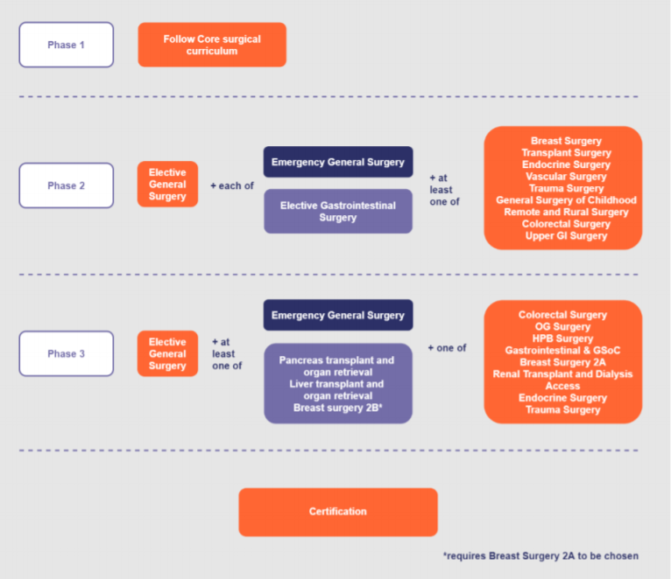
- All trainees will complete modules in elective and emergency general surgery at phase 2 – they will be able to manage the pre & post-operative care of the unselected emergency take. Additionally, 80-85% of general surgical trainees will complete training in emergency general surgery at phase 3; they will be able to perform common emergency general surgical operations fluently without guidance or intervention and be able to anticipate, avoid and/or deal with common problems/complications.
- Competency will be assessed across 2 areas with equal weighting given to both. These are the General Medical Council (GMC) Generic Professional Capabilities (GPCs) common across all medical curricula (appendix 1) and new surgical Capabilities in Practice (CiPs); which directly reflect areas of surgical consultant working.
- Areas of GPCs particularly pertinent to simulation training are:
  - Domain 2 Professional Skills
    - Practical Skills
    - Communication & interpersonal skills
    - Dealing with complexity & uncertainty
    - Clinical skills
  - Domain 5 Capabilities in leadership & teamworking
- The 5 new CiPs are:
1. Manages an out-patient clinic
2. Manages the unselected emergency take
3. Manages ward rounds and the ongoing care of in-patients
4. Manages an operating list
5. Manages multi-disciplinary working
- The new curriculum identifies that simulation should be used as part of a blended learning approach for delivery of training; running concurrently with supervised clinical practice. It identifies simulation as a useful methodology for development of technical skills, team-working, leadership, judgement and professionalism.
Proposed Simulation Strategy for Higher Surgical Training to be piloted in General Surgery
- The strategy will be focussed, in line with Shape of Training recommendations, on the development of general surgical elective and emergency training. It will be delivered during phase 2 of the training programme. Phase 2/3 specialist modules are diverse and beyond the scope of a national programme. Many robust courses/fellowships already exist to allow the development of these specialist skills.
- The aim of the simulation programme is to:
  - Accelerate acquisition of new skills to enable trainees to use these skills earlier in supervised clinical practice
  - Maintain skills that are used less frequently
  - Support training in, and allow safe practice of, decision making/leadership/teamworking, particularly in areas commonly reserved for consultant practice (ie MDT decision making)
- The Scottish higher surgical simulation strategy aims to build on the same principles set-out in the Scottish Improving Surgical Training pilot. This has been focussed on developing a culture of regular personal/in-house simulation-based training, addition of simulation to existing monthly teaching programmes and occasional courses; including an enhanced induction ‘Bootcamp’. This strategy recognises the need for repetitive deliberate practice of skills with feedback as the foundation to developing and enhancing skills. The IST Sim programme can be seen below.

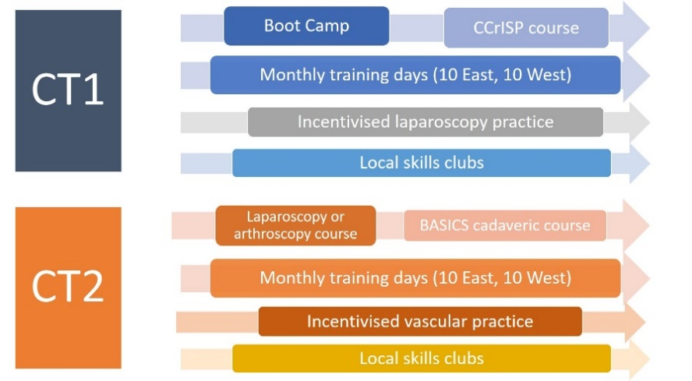

- The proposed higher surgical simulation strategy can be seen below. Each element can be seen mapped to the new surgical curriculum in Appendix 2.
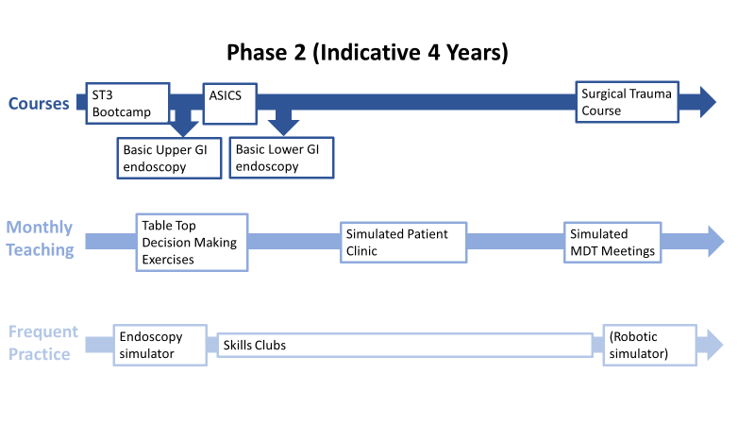
Courses
- Bootcamp
A 3-day enhanced induction programme, ‘Bootcamp’ has been piloted for trainees based in the West of Scotland at the Medical Education Training Centre, Kirklands for the past 2 years. The programme allows full orientation to the Intercollegiate Surgical Curriculum Project (ISCP) training platform and setting of expectations for higher training. Simulated elements include ward round, clinic, MDT and surgical skills. It includes workshops on letter writing, vetting referrals and running virtual clinics.
- ASICs (Advanced Surgery Cadaver Skills in GI Surgery)
This is a 1 day cadaveric course to introduce common general surgical operations. It builds on the basic skills/procedures introduced during the IST pilot in the BASICS course. The course includes training in laparoscopic cholecystectomy, management of duodenal perforation, right hemi-colectomy, splenectomy, subtotal colectomy and Hartmann’s procedure.
- Basic Endoscopy Courses
Basic upper & lower GI endoscopy courses are already a feature of surgical training; and currently centrally funded for Scottish trainees through NHS Education for Scotland (NES). The new general surgical curriculum has set new expected numbers of upper GI endoscopy & colonoscopy, aligned to JAG (Joint Advisory Group on GI Endoscopy) accreditation, prior to awarding a certificate of completion of training (CCT). These numbers are recognised as challenging to achieve within the surgical curriculum and renewed emphasis on early acquisition of skill to allow steady accumulation of cases is required. These basic endoscopy courses need to be completed early within phase 2.
- Trauma Course
The majority of trainees will be expected to be fully competent in the operative management of the emergency surgical take. This will include some trauma. Major trauma cases are high risk/low frequency events for the majority of surgical consultants. Current practical exposure to surgical trauma management is ad hoc based on clinical exposure on trainee placement. The concentration of trauma within regional trauma centres will potentially further reduce trainee exposure; while demanding a workforce able to fulfil the role.
A one day cadaveric trauma course aligned to the expected competencies of a general surgery consultant will ensure exposure and practice of surgical management of trauma for all trainees. The course will be delivered in conjunction with trauma leads from the Scottish Major Trauma Centres.
Monthly Teaching
- Annual simulated sessions will be co-ordinated nationally and run regionally as part of existing monthly teaching sessions. The aim is to run 3 sessions annually using a combination of table top decision-making exercises, simulated patient consultations or simulated multi-professional MDTs. These sessions will utilise a combination of face-to-face and on-line meetings. The sessions will allow discussions around complex issues such as consent and capacity or bed flow/management issues. These sessions will mirror those of the HST bootcamp and allow repetition and deliberate practice of skills over phase 2 training.
- Each session is aligned to the curricular CiPs; and inclusive of some of the generic professional capabilities; such as professional values & behaviours; health promotion and illness prevention; safeguarding vulnerable groups.
- Sessions will enable discussion around the Non-Technical Skills for Surgeons (NOTSS) namely situation awareness, decision making, teamwork & communication and leadership; revisiting and practicing elements established within the Scottish IST pilot.
Frequent Practice
- Endoscopy Simulator
NES have funded 6 endoscopy simulators to be situated across training regions from early 2021. These provide the opportunity to accelerate the early acquisition of endoscopy skills to allow an early transition to full patient procedures. This should facilitate earlier accumulation of the necessary number of procedures for CCT. To be most effective trainees new to endoscopy should be offered dedicated training sessions to practice on the simulators. Ideally these should be scheduled sessions during the working day until technical competence is reached to maximise the experience within clinical endoscopy sessions.
- Skills Clubs
In-hospital Skills Clubs have been promoted within the Scottish IST pilot to facilitate regular practice of practical skills such as suturing, hand-tying and bowel anastomosis. They are part of a wider drive to move training culture toward an expectation of deliberate practice and competency prior to patient contact. Having set this expectation through the IST pilot the aim is to continue this into higher surgical training. To be effective there must be scope to include new skills to challenge the higher surgical trainee, or low frequency skills that need to be maintained. Examples could include laparoscopic suturing, bile duct exploration or more complex anastomotic techniques.
- (Robotic Simulator)
Over the coming year Scottish Government will invest in several robotic systems for use within general surgery. While initial training will be focussed on established consultants it is expected that over time trainees will also require training in this new modality. Simulators are in-built within the robotic platforms and should be utilised towards the end of Phase 2 in a manner similar to endoscopy simulators, or as part of a wider Skills Club format.
Leadership
To ensure its success the proposed strategy will require national co-ordination, quality assurance and evaluation. In line with similar programmes this will require appointment of an experienced clinician in a Simulation lead role with administrative support.
Costs
The Cost table overleaf is based on the assumption of 30 ST/LAT trainees each year, a total of 120 within the ST3-ST6 target cohort ie during Phase 2 of the new curriculum. Current numbers range 20-34 trainees / ST year, a total of 113 trainees in the current ST3-ST6 cohort (see appendix 3).
Overall the cost/trainee/year is £1153 in year 1, and £1053 over subsequent recurring years. Cost is unequally distributed across training years as courses are concentrated in transition years (ST3 & ST6). The approximate differentiated costs /year are as follows:
Training Year | Year 1 Cost/Trainee | Subsequent Recurring Cost/trainee/year
ST3 | £1908.76 | £1734.44
ST4 | £654.70 | £597.99
ST5 | £654.70 | £597.99
ST6 | £1392.38 | £1271.78

Table 1: Estimated Costs of Sim Strategy
Sim Element | Unit cost |  | No of trainees year 1 | Year 1 funding | Estimated recurring yearly costs%
Boot camp | £500 |  | 28 | £14,000 | £15,000
ASICS | £705 |  | 28 | £19,740 | £21,150
Endoscopy courses | Separate NES funding |  |  | £0 | £0
Trauma Course | £710 |  | 29 | £20,590 | £21,300
Table top exercises*$ | £10 |  | 121 | £1,210 | £1,200
Simulated clinic* | £70 |  | 121 | £8,470 | £8,400
MDT*$ | £10 |  | 121 | £1,210 | £1,200
Endoscopy simulators | Nil (existing equipment) |  |  | £0 | £0
Skills Club: EOSIM laparoscopic trainers# | £1,198 |  | 10 | £11,980 | £0
Skills Club: sutures^ | £155.71 |  | 121 | £18,841 | £18,685
Robotic simulator | Nil (existing equipment) |  |  | N/A | £0
Clinical Lead | 2 PAs |  |  | £26,601 | £26,601
Admin support | 0.4WTE |  |  | £12,800 | £12,800
Total cost |  |  |  | £135,442 | £126,336
Simulation cost per trainee (30 x 4 years ST3-ST6) |  |  | 120 | £1,119 | £1,053

*Faculty costs not included – expected will come from existing SPA time
$Facility costs not included – expected will run within existing teaching facilities +/- online
#Estimate to ensure all Skills Clubs have laparoscopic box trainer based within hospital
^Estimate based on 1 x box sutures/trainee/year
%Based on approximately 30 trainees per year

Conclusion
This simulation strategy aims to utilise proven simulation-based medical education techniques within high value areas of the surgical curriculum. It aims to maximise use of existing and new infrastructure and use regular low-cost, in-house simulation as the foundation to skills development. It builds on the principles established within the Scottish IST pilot programme to evolve training culture to one of practice to competency prior to patient contact. The simulation elements have been placed to support training in challenging areas of the curriculum; particularly in aspects of senior decision making, endoscopy training and trauma and are aligned to the new assessment criteria within the new curriculum.

Appendix 1: Generic Professional Capabilities
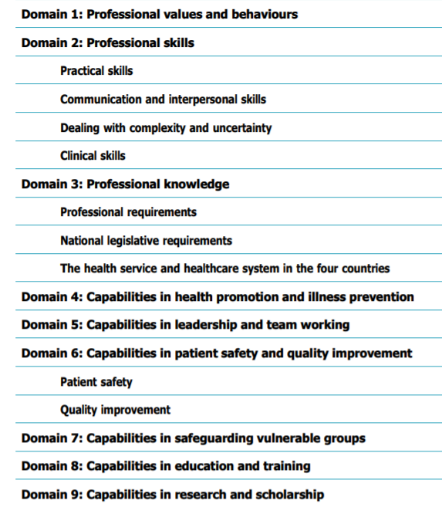

Appendix 2: Mapping of Simulation Components to Curriculum
Sim Element | Generic Professional Capabilities |  |  |  |  |  |  |  |  | Competencies in Practice
Sim Element | Domain 1: Professional Values & behaviours | Domain 2: Professional Skills | Domain 3: Professional Knowledge | Domain 4: Capabilities in health promotion & illness prevention | Domain 5: Capabilities in leadership & teamworking | Domain 6: Capabilities in patient safety & quality improvement | Domain 7: Capabilities in Sasfeguarding vulnerable groups | Domain 8: Capabilities in educated & training | Domain 9: Capabilities in research & scholarship | 1. Manages an outpatient clinic | 2. Manages the unselected emergency take | 3. Manages ward rounds and ongoing care of in-patients | 4. Manages an operating list | 5. Manages multidisciplinary working
Courses
Bootcamp
Basic upper/lower GI endoscopy
ASICs
Trauma Course
Monthly teaching
Table-top Decision making exercises
Clinic
MDT
Regular practice
Endoscopy simulator
Skills Clubs
(Robotics)

Appendix 3: Expected Numbers of ST/LATs per year of higher surgical training in General Surgery in Scotland during 2021/22
Grade | North | East | South East | West | Total
ST3 | 5 | 4 | 8 | 11 | 28
ST4 | 5 | 3 | 4 | 18 | 30
ST5 | 8 | 5 | 5 | 16 | 34
ST6 | 1 | 1 | 5 | 22 | 29
Total | 19 | 13 | 22 | 67 | 121

