Medical ACT Stakeholder Engagement Day 5
Summary of Discussions and Stakeholder Feedback

Tuesday 5th November 2024

-----------------------------------------------------------------
 |  |  |  | 

Overview
The 5th Medical ACT Stakeholder event was held on 5th November 2024 online and once again was facilitated by Graham Paxton (Principal Lead, Organisational Development Leadership and Learning).
Professor Emma Watson and Mr Jim Boyle welcomed delegates and set the scene for the discussions on the agenda. 55 delegates attended and were thanked for their continuous engagement with this and all previous engagement events.
The aims for the session were to continue the conversations from previous Stakeholder Engagement events and discuss short term changes to the MoT process and further consider and explore some medium-term changes. Additionally, the event aimed to update stakeholders with the NES Capital Planning processes and financial governance arrangements.
Laura Howard (Deputy Director of Finance) opened with an overview of the current NHS Scotland financial position. Ellie Biddulph and Alastair Campbell led an overview of the short-term changes to the MoT data collection process. Following this, a small groups discussion task considered aspects of how Medical Programmes and NHS Boards might collaborate around planning of the delivery of a clinical curriculum with support from NES with the aim of Boards achieving a better understanding their Medical ACT allocation in a prospective way. These discussions are detailed in the following pages.

Attendance
 | August 23 | November 23 | March 24 | June 24 | November 24
Total Attendance | 44 | 47 | 48 | 51 | 55
In person | 36 | 21 | n/a | n/a | n/a
Online | 8 | 26 | 48 | 51 | 55
Directors of Medical Education | 12 | 6 | 12 | 13 | 13
Medical Education Manager | N/A | 10 | 8 | 9 | 7
Medical ACT Officer | N/A | 4 | 5 | 4 | 5
Medical ACT Finance Representatives | 9 | 6 | 4 | 5 | 5
UG Programme Leads | 5 | 7 | 4 | 3 | 5
GP Head of Teaching | 3 | 4 | 4 | 3 | 3
Other - including NES Team | 17 | 10 | 11 | 14 | 17

Short Term changes to MoT

Ellie Biddulph and Alastair Campbell outlined the previously agreed short term changes to the MoT data collection process which will be used during 2024/25. These include:
- The addition of a ‘Programme Movement’ tab to the MoT template which is due for submission in December 2024. This is intended as a visual tool to help make the impact from MoT data on future funding clearer.
- The ‘Programme Movement’ page will pre-populate when the MoT template is completed. Any movement in MoT data used for the 2024/25 allocation process can be demonstrated against the most recent MoT submission used to allocate funding for 2025/26.
- This visual tool should help Boards to identify any unintended data errors at an earlier stage, highlight the impact of teaching changes on funding and summarise the multi-programme impact on an individual Board’s funding.
- Following previous feedback regarding the complexity of gathering Category B data for this year’s MoT submission, Programmes can choose if they wish to use their previous years’ data again this year. However, Programmes are also allowed to submit a new dataset if that is preferred.
- All DMEs will be involved in signing off their data to indicate that it provides a fair representation of the teaching and education delivered.
- The regional Medical ACT Officers and NES Finance team can provide support where needed.

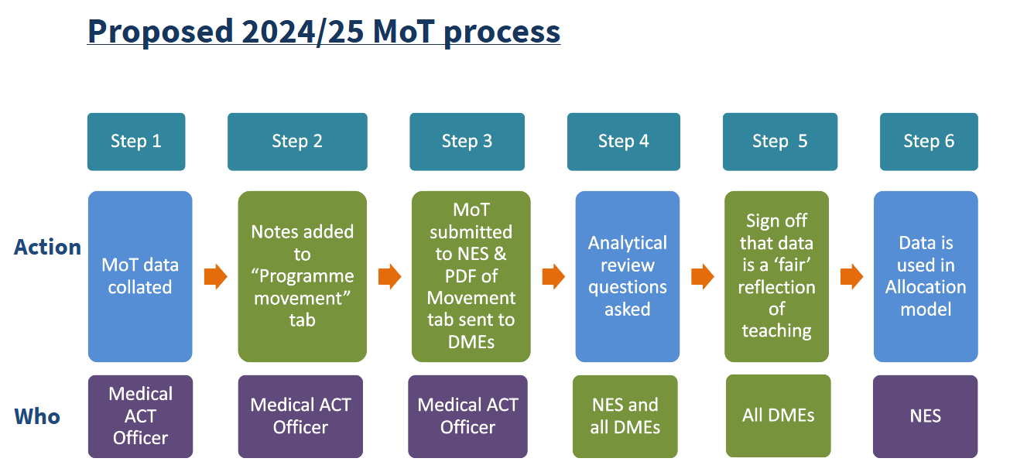
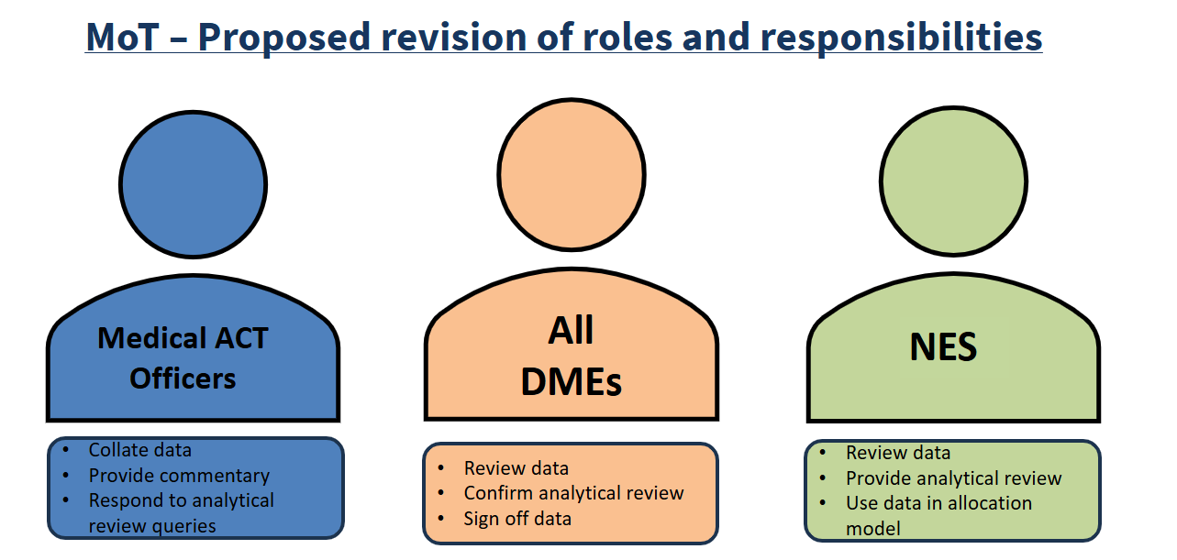

Capital Planning & Financial Governance
Laura Howard provided an overview of the 2024/25 Capital Planning budget relating to Medical ACT
- NHS Scotland Annual Capital Budget is £315m
- There is an ageing estate and also a need to increase educational infrastructure capacity.
- In 2023/24 NES sought approval from Scottish Government for NES to support Boards by converting revenue funding to capital for Medical ACT
- NES will support capital infrastructure programmes only. However, Boards can still apply directly to SG for revenue to capital transfer where necessary for other items
- Capital Planning is essential to ensure a sufficient level of funding is available.

The expected Governance Arrangements for Capital Infrastructure bids using Medical ACT funding are outlined below:
- Boards must submit a business case for all capital infrastructure bids. There is no set format for this therefore NES can accept cases written to local standards.
- Business cases need to be reviewed and approved by local finance team and other Board governance routes before submission to NES.
- Once submitted, within NES there are several further routes to navigate, depending on the total funding amounts required to deliver the project.
- The steps involved are outlined in the infogram ‘Timeline for Approval of Capital Infrastructure Bids’ below, along with indicative timelines needed to progress.

Timeline for Approval of Capital Infrastructure Bids 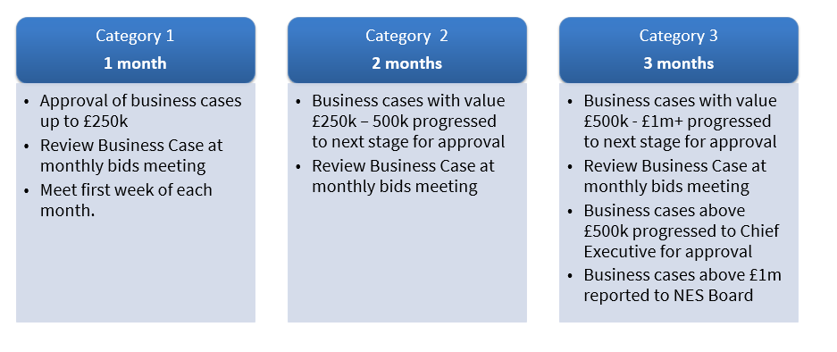

Medium Term Changes to MoT Process Programme Communication Forum

Group Discussion
Attendees were split into 5 groups according to their base regions with NES teams assigned to each group. Each group was asked to consider one of the following questions as follows:
Secondary Care focus
- How can a medical programme’s needs be delivered clinically and sustainably in Boards?
Who needs to be involved in the process?
- How does a Board’s capacity and Medical ACT budget influence these conversations?
- What factors are considered by a Board when deciding to provide teaching for more than one medical programme?
Primary Care focus
- What different models are emerging for delivery of Primary Care teaching?
Who and what needs to be considered before the decision to implement?
- How is placement capacity in Primary Care considered at NHS Board level and what opportunities are there for improved management of capacity issues?

Feedback for each question is recorded below:

Group 1 – How can a medical programme’s needs be delivered clinically and sustainably in Boards?  Who needs to be involved in the process? | Group 2 – How does a Board’s capacity and Medical ACT budget influence these conversations? | Group 3 – What factors are considered by a Board when deciding to provide teaching for more than one medical programme? | Group 4 – What different models are emerging for delivery of Primary Care teaching?  Who and what needs to be considered before the decision to implement? | Group 5 – How is placement capacity in Primary Care considered at NHS Board level and what opportunities are there for improved management of capacity issues?
Review and change curriculums | Boards capacity and Medical ACT budget are both critical and influence conversations | Capacity within the clinical service? Is there a balance of providing teaching and clinicians workload? | Set number of teaching hours | Increasing tensions due to overlap between programmes in regions
Sustainability is a concern in Glasgow, increasing pressure for clinicians so they have less teaching time | Requires both parties to ensure curriculum changes are feasible, achievable, affordable and deliverable. | If a Board is considering taking students from a non-existing school – does that affect relationships? | Lay out reasons for changes / benefits / down falls | GP are independent and so communication (Board/Practice/Programme) can be an issue
Be more reliant on Clinical Teaching Fellows – note that CTFs are there all year but students are not | Pressures from Universities to achieve good student feedback affect the status of the University but there may be an expectation mismatch between the expectations of the students and what the NHS can deliver. | Accommodation | Can the University / Board afford it | Funding lies with Boards however quality and teaching outcomes are not always visible to them
Everyone needs to be involved | Students have high expectations and expectations aren’t always in keeping with what provision the NHS can make. | Difficulties which arise when sending a student to a specific / new school if expectations are not met as they operate differently | Equitable and sustainable teaching | Missed opportunities for identifying capacity in Boards as they have no oversight of placements
Ensure collaborative working between Boards and Schools | Capacity is wide ranging depending on accommodation, teaching facilities, resting areas so is much broader than initially thought | Are Boards delivery drivers or are they co-creators? | How will it be delivered? | Students being lost through the process
As curriculums are developed, schools should have regular check ins with DMEs | Appreciate other Boards/Programmes challenges – this will enable delivery. | Programmes and Boards working more closely from the beginning and noted this should be embraced as changes could be made more seamlessly | Adding barriers (for example, set number of teaching hours) | Boards may have a source of information going to Health Boards but this is not communicated
Look at sustainability around students and travel |  | Support for Students | Look at evidence to drive and make decisions. | Communication around capacity and teaching requirements could be improved
 |  | Available resources |  | ScotGEM in D&G is a successful model where it is integrated in hospital and GP
 |  |  |  | GP teams and DMEs need to communicate better around governance.
 |  |  |  | ADME for primary care who is a GP

Summary of Group Discussions
No major new changes to MoT will be implemented for 2024/25 beyond the short term changes summarised below which were agreed at this event.

- NES proposes that the ‘Programme Movement ‘tab is used as a pilot for this year’s MoT submission. Feedback provided from Boards will be helpful to understand whether this is a useful development going forwards.
- Category B data for this year’s MoT submission can be re-submitted from previous years but NES will accept a new submission if the Board prefers to do that
- Following feedback from this event, more discussion is required on future changes to Category B categories to ensure a more workable solution is reached longer term
- The suggested guidance for capital planning bids to be implemented by NES and Boards with immediate effect.
- The importance of collaboration and discussion at early stages between Boards and Programmes was highlighted and it may be helpful to test out the concept of a “Programme Communication Forum” to explore whether this might be a useful development from 205/26 onwards.

Next Steps
Professor Alan Denison closed the event by thanking all for their attendance and helpful contributions across the afternoon. A further event will be scheduled in 2025.
Any further comments on the event or the information contained in this summary may be submitted to nes.medicalact@nhs.scot

